**east west university**

**Lab Report - 04**

**Department:** **Computer Science and Engineering**

**Course Title:** Digital Image Processing

**Course Code:** CSE438

**Section No:** 02

**Submitted To**:

Dr. Engr. Ahmed Wasif Reza

Associate Professor, Department of Computer Science and Engineering

**Submitted By**:

Name: S M Arafat Rahman

ID: **2019-2-60-094**

**Question – 01**

**b)**

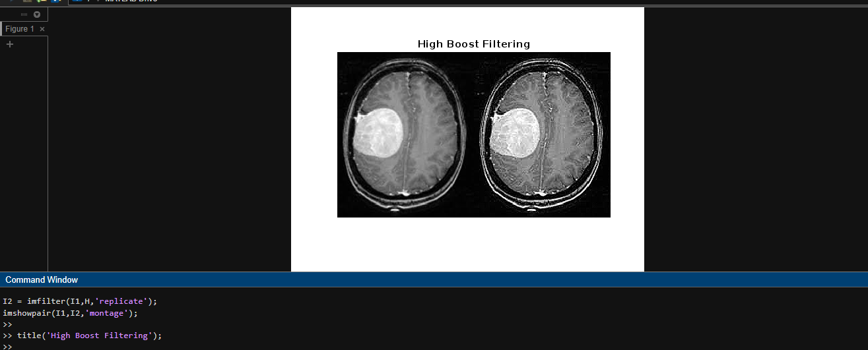

Code:

I1 = imread('tumor.png');

H = [0,-1,0;-1,5,-1;0,-1,0];

I2 = imfilter(I1,H,'replicate');

imshowpair(I1,I2,'montage');

**a)**

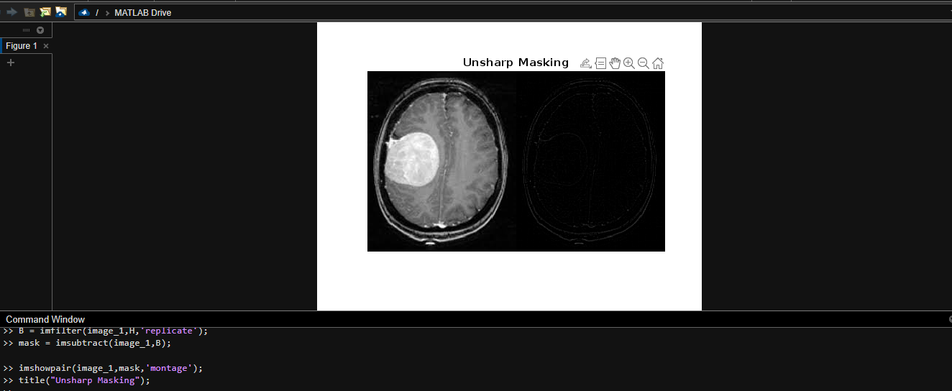

Code:

image_1 = imread('tumor.png');

H=ones(3)/9;

B = imfilter(image_1,H,'replicate');

mask = imsubtract(image_1,B);

imshowpair(image_1,mask,'montage');

**Question – 02**

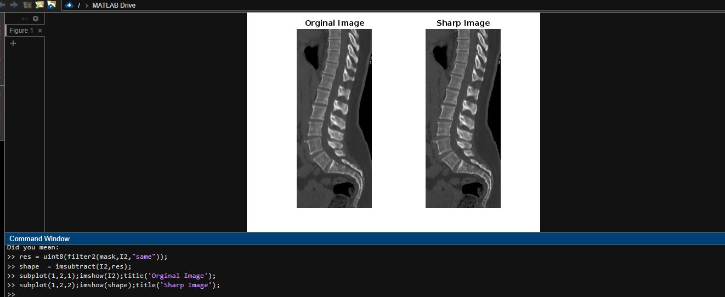

Code:

I2 = imread('Spine_CT.png');

I2 = rgb2gray(I2);

mask = [0 1 0; 1 -4 1; 0 1 0];

res = uint8(filter2(mask,I2,"same"));

shape = imsubtract(I2,res);

subplot(1,2,1);imshow(I2);title('Orginal Image');

subplot(1,2,2);imshow(shape);title('Sharp Image');

**Question – 03**

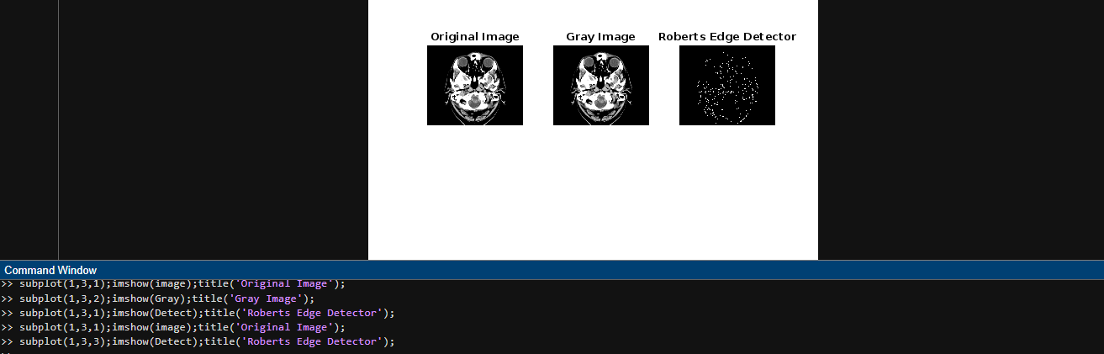

Code:

image = imread('Head_CT_Scan.png');

Gray = rgb2gray(image);

Detect = edge(Gray,'roberts');

subplot(1,3,1);imshow(image);title('Original Image');

subplot(1,3,2);imshow(Gray);title('Gray Image');

subplot(1,3,3);imshow(Detect);title('Roberts Edge Detector');

**Question – 04**

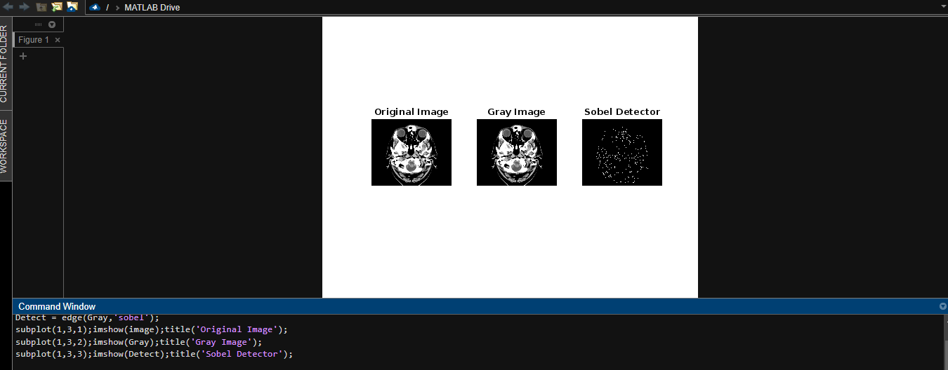

Code:

image = imread('Head_CT_Scan.png');

Gray = rgb2gray(image);

Detect = edge(Gray,'sobel');

subplot(1,3,1);imshow(image);title('Original Image');

subplot(1,3,2);imshow(Gray);title('Gray Image');

subplot(1,3,3);imshow(Detect);title('Sobel Detector');

**Question – 05**

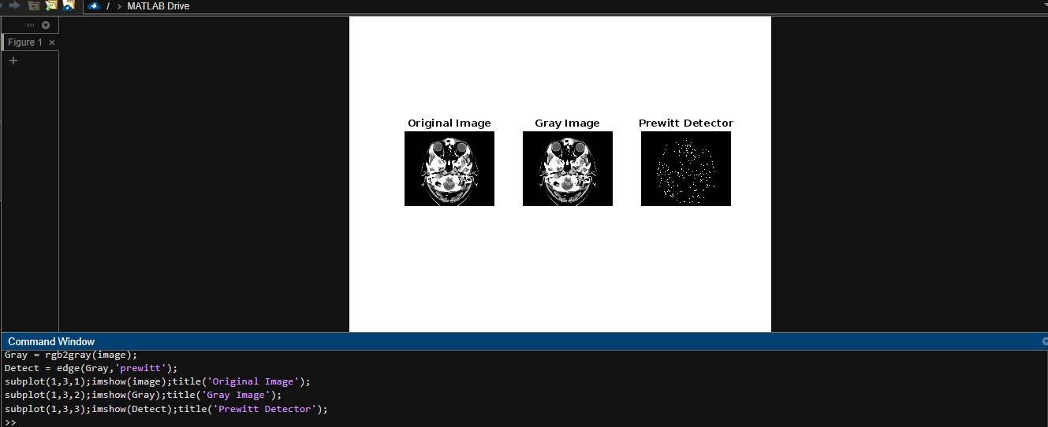

Code:

image = imread('Head_CT_Scan.png');

Gray = rgb2gray(image);

Detect = edge(Gray,'prewitt');

subplot(1,3,1);imshow(image);title('Original Image');

subplot(1,3,2);imshow(Gray);title('Gray Image');

subplot(1,3,3);imshow(Detect);title('Prewitt Detector');